|  |  |  |
| --- | --- | --- |
| **Experiment No - 10** |  | **Date: 19/4/22** |

**Aim of the Experiment: Write a program in python to solve any one AI problem**

**Theory :**

8 Puzzle Problem:

Given a 3×3 board with 8 tiles (every tile has one number from 1 to 8) and one empty space. The objective is to place the numbers on tiles to match the final configuration using the empty space. We can slide four adjacent (left, right, above, and below) tiles into the empty space.

**Source Code :**

Below is the code of 8 Puzzle Problem

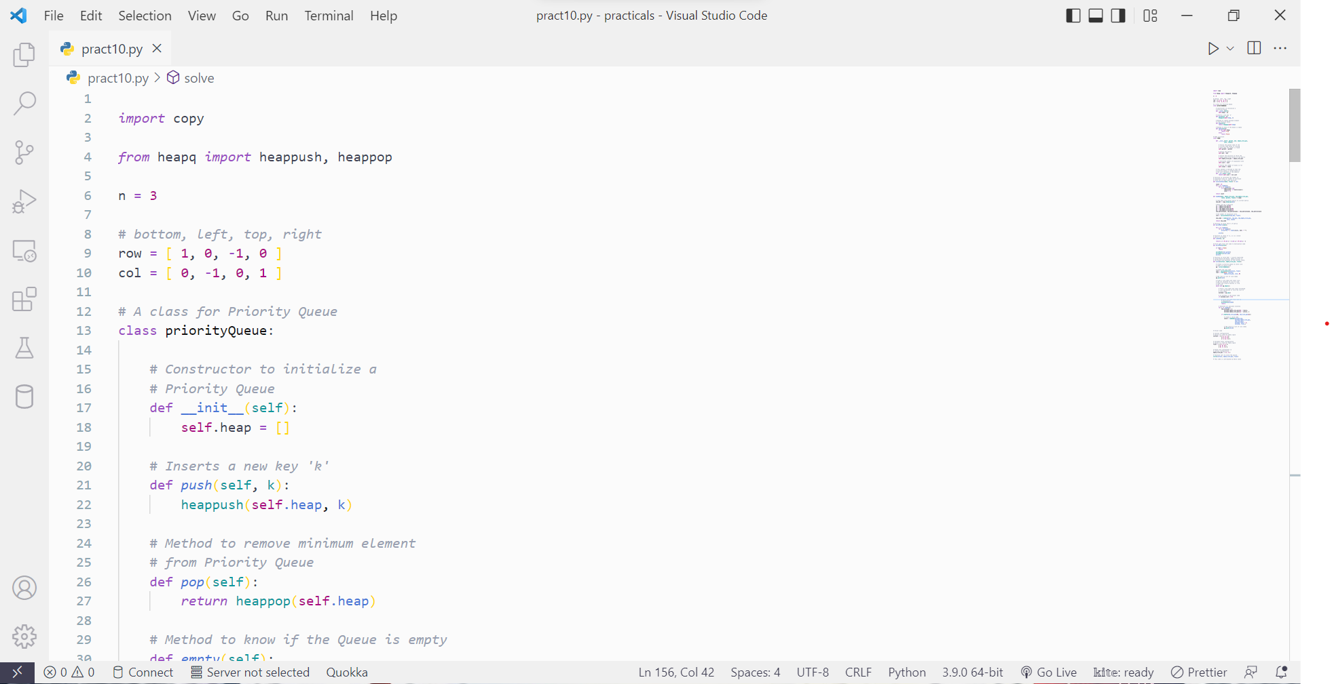

*Fig 10.1 Source Code*

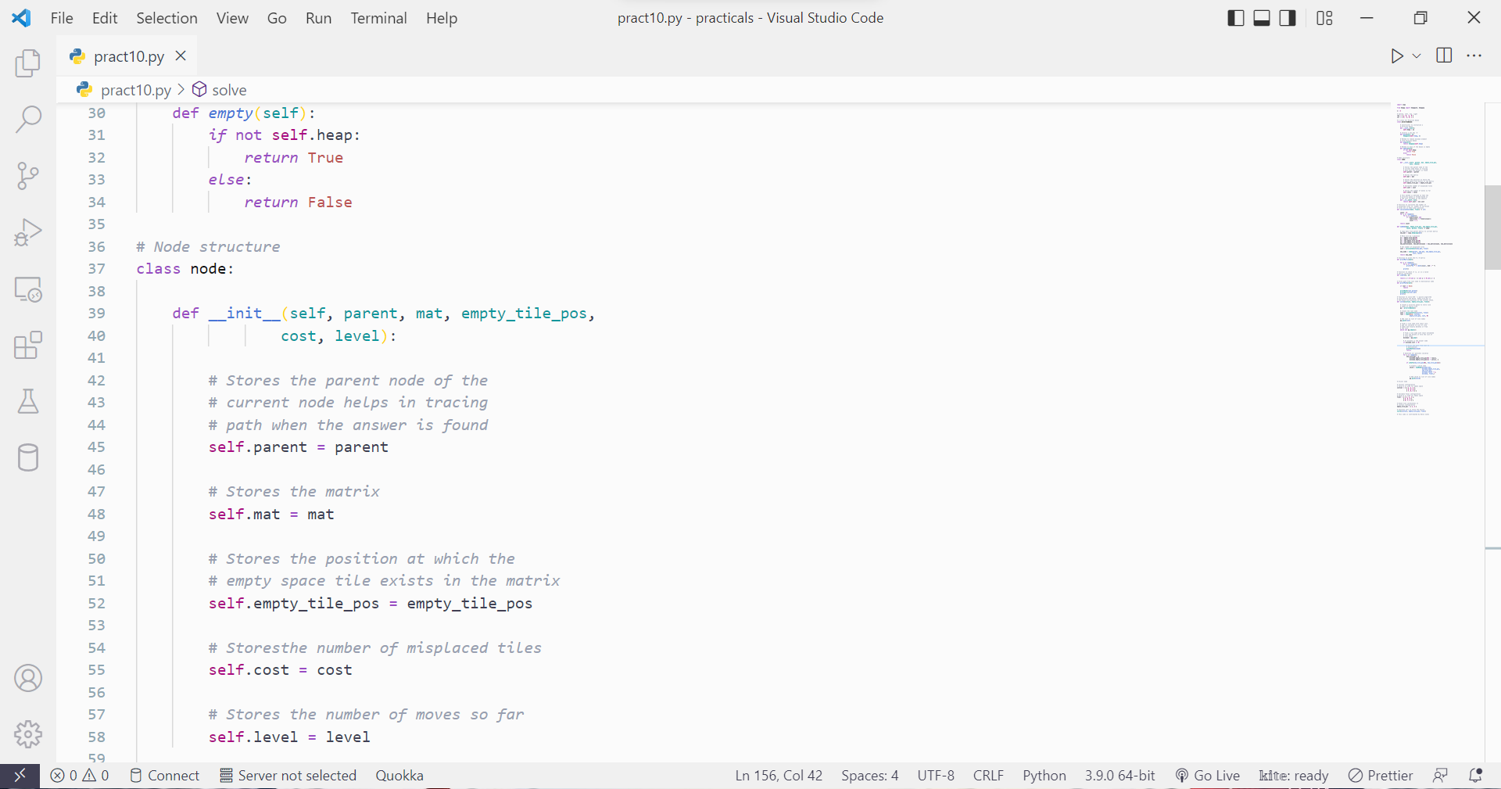

*Fig 10.2 Source Code*

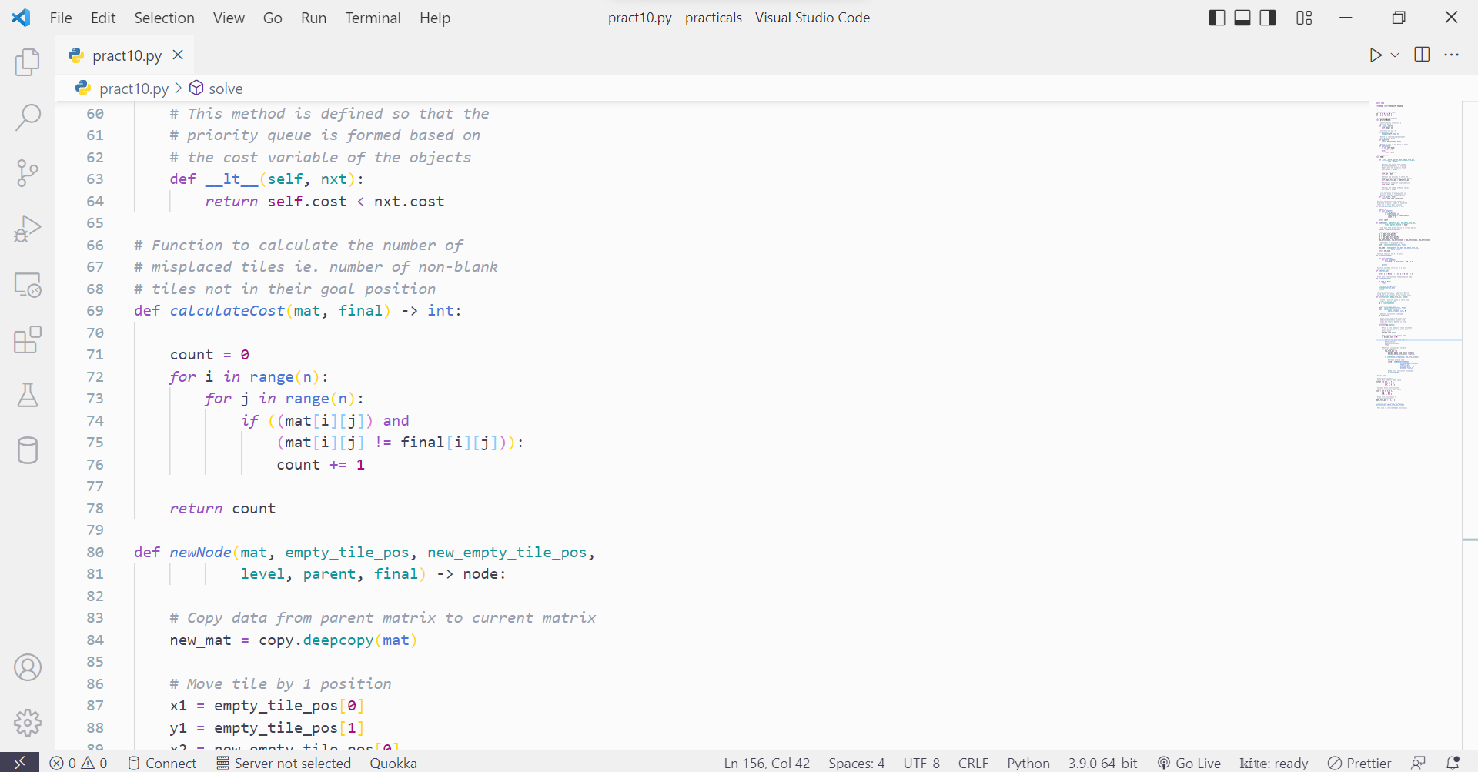

*Fig 10.3 Source Code*

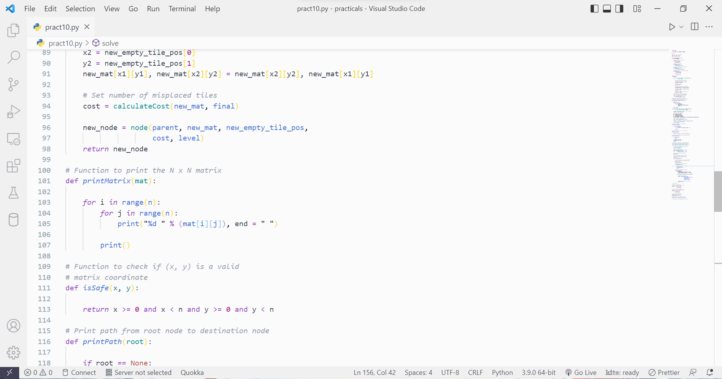

*Fig 10.4 Source Code*

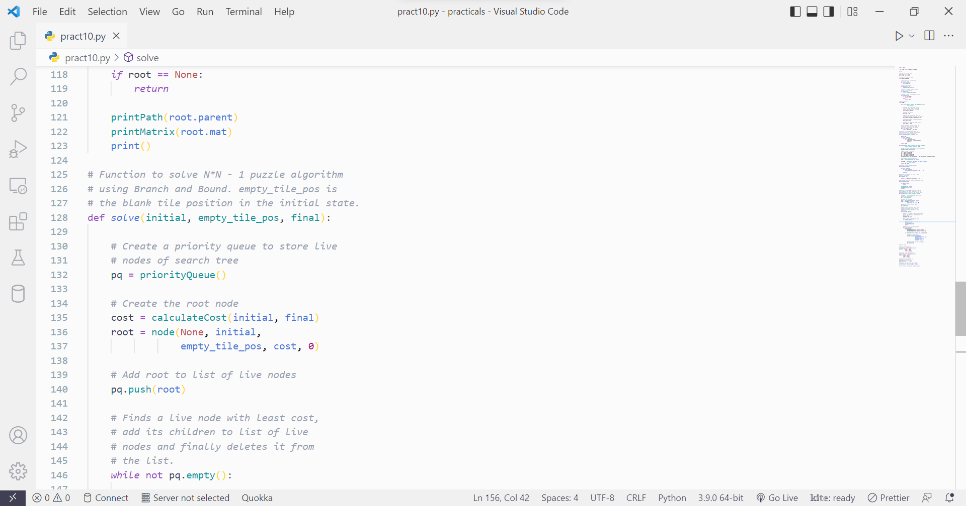

*Fig 10.5 Source Code*

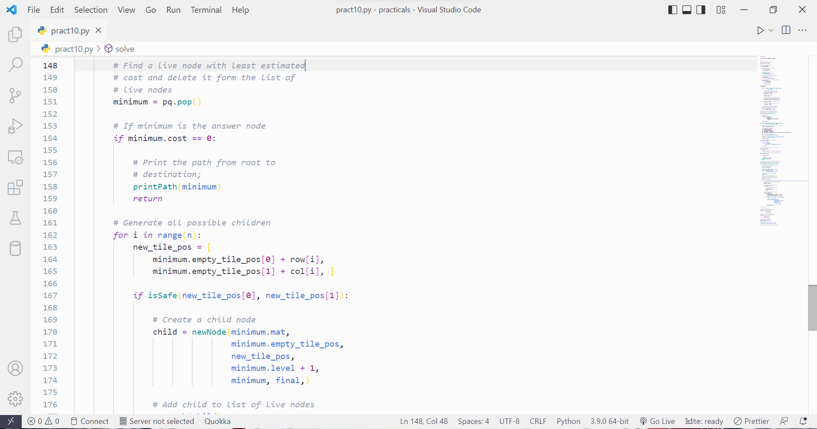

*Fig 10.6 Source Code*

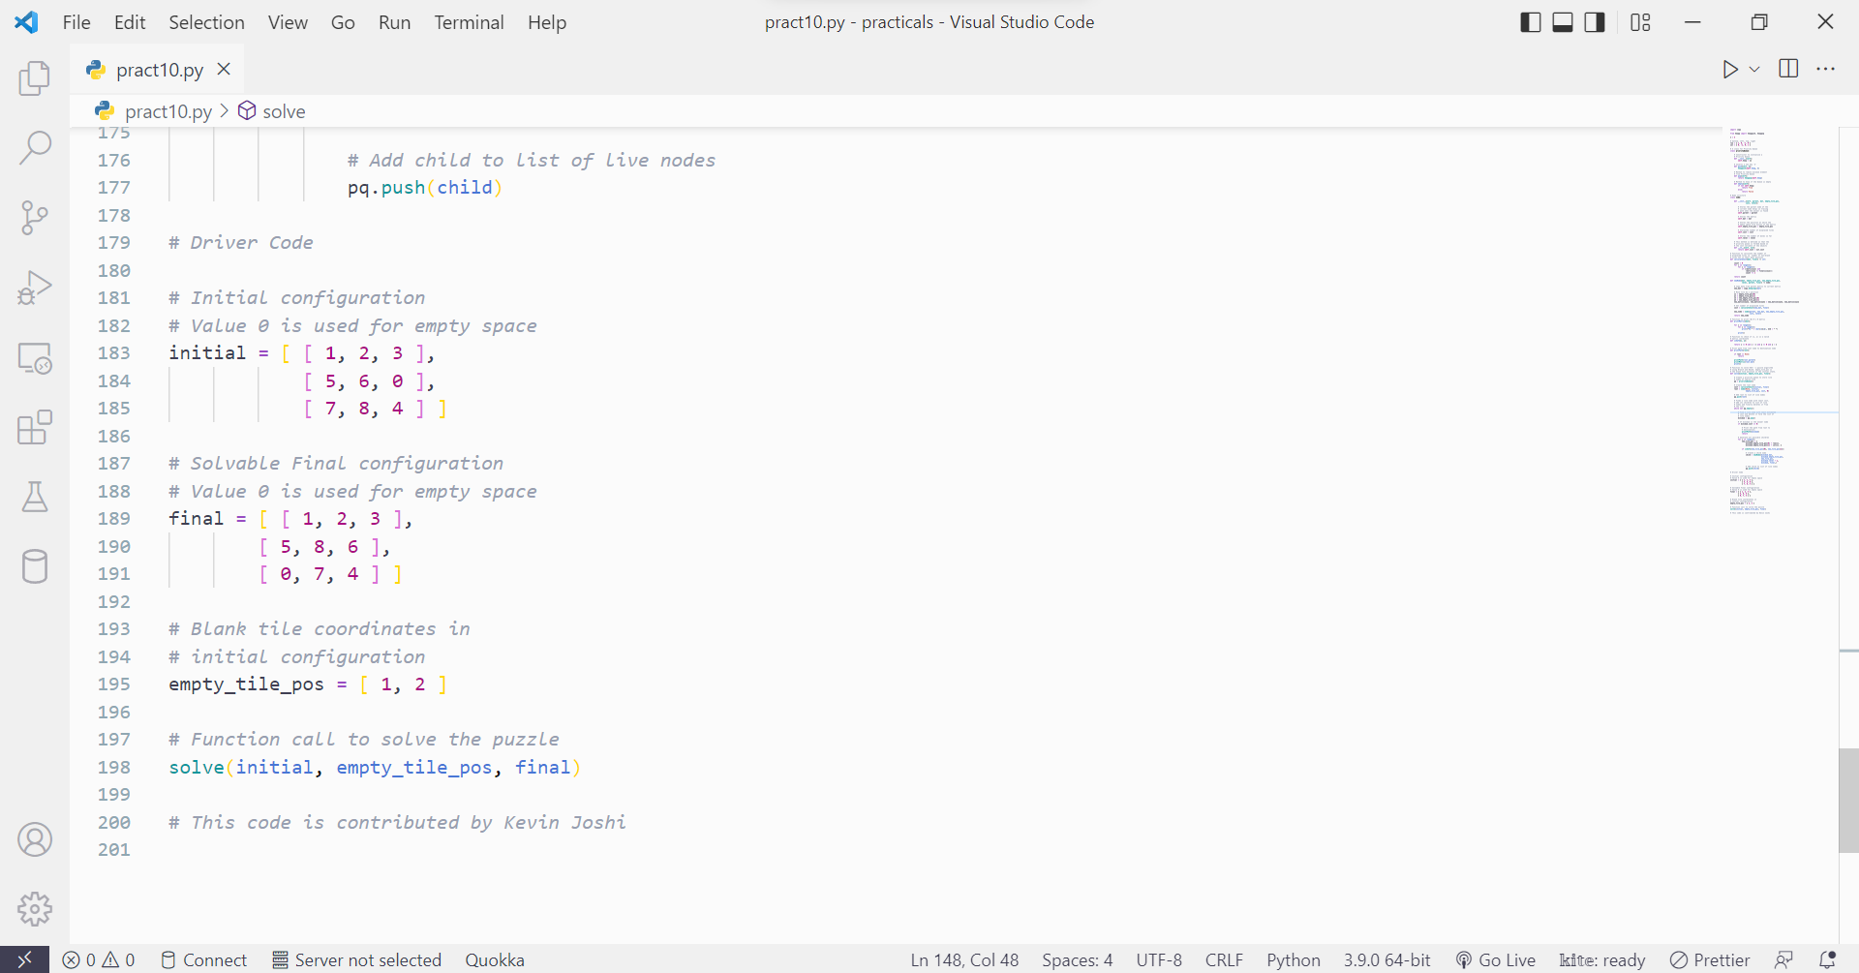

*Fig 10.7 Source Code*

**Output :**

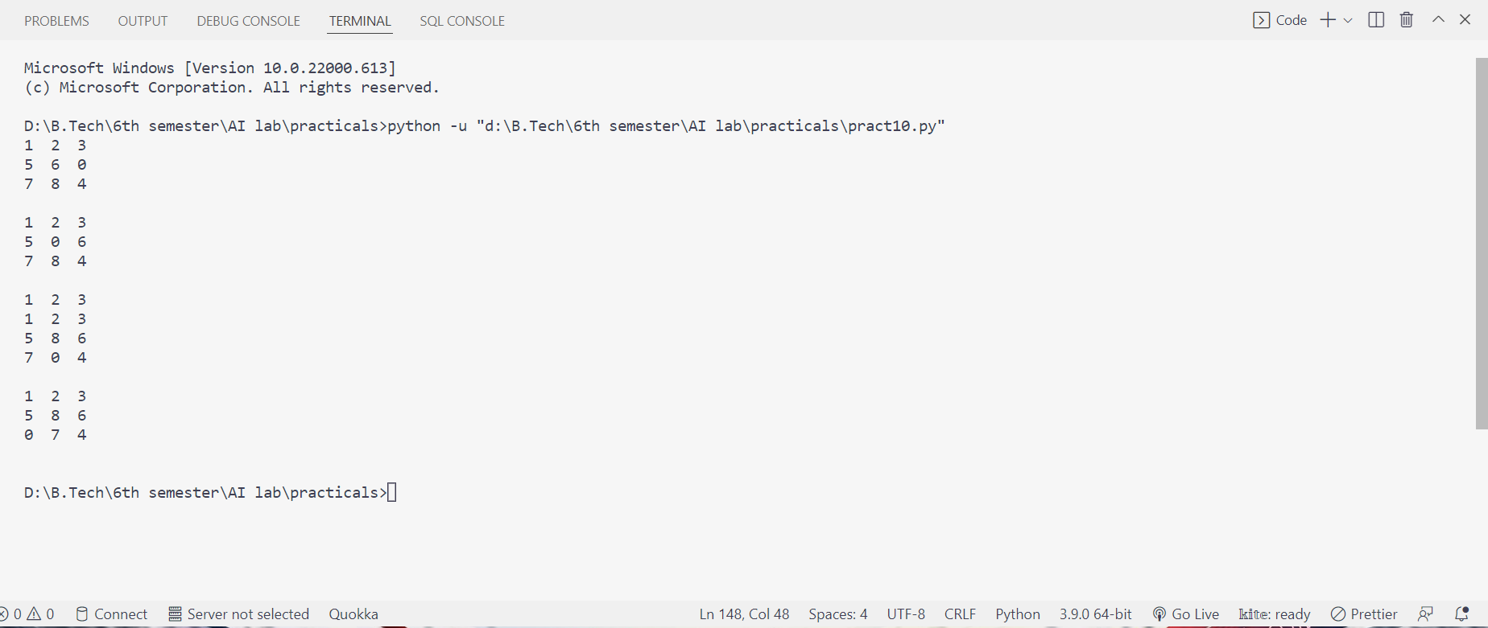

*Fig 10.8 Output*